**SMART INDICATION SYSTEM**

BY - ATHARVA GODKAR

INDEX

|  |  |  |
| --- | --- | --- |
| SERIAL NO. | CONTENT | PAGE NO. |
| 1. | AIM |  |
| 2. | THEORY |  |
| 3. | BLOCKDIAGRAM |  |
| 4. | CIRCUIT DIAGRAM |  |
| 5. | HARDWARE & SOFTWARE |  |
| 6. | WORKING |  |
| 7. | PCB MAKING |  |
| 8. | ADVANTAGES & APPLICATIONS |  |
| 9. | RESULT |  |
| 10. | FUTURE SCOPE |  |
| 11. | TOTAL COST |  |
| 12. | REFERENCES |  |
| 13. | RESEARCH PAPERS |  |
| 14. | CHALLENGES |  |

AIM

The aim of the project was to develop a turn indication system for 2 wheelers that will automatically give signals based on position of steering wheel.  This will reduce the miss communication between bike riders & also improve  visibility of vehicle on road during night time. In short it will reduce  accidents. I also made a webpage that helps to monitor the activities of  cyclist and do live location tracking. This will help in immediate medical  assitance to the victim incase of an accident.

PROBLEM STATEMENT

With the increase in prices of crude oil more and more people are switching to electric cycles for purpose of transportation. Keeping this in mind the safety of cyclist becomes a topic of major concern. In India there are no separate roads for cyclist as such. Traditional cycles available in market do not have any of those features which are available in two wheelers. For example, speedometer, odometer, turn indication, fall detection etc. Around 1 million bicycle accidents happen every year from which 35,000 are fatal. And most of these accidents are due to the reason bicyclist are invisible to the motor vehicles passing by. Also, when a cyclist meets with an accident he is not immediately taken to the hospital. By the time medical help arrives the condition of cyclist becomes critical.

PROPOSED SOLUTION

Keeping this problem in mind we have come up with a solution. Our idea is to upgrade the normal bicycles by installing sensors and LED on it. Sensor will help to give the direction in which vehicle is going to take turn. Many people in India donot use indicators and even if the use they forget to turn it off. This creates lot of confussion on road. We have automated this process thereby reducing the workload of cyclist. The same sensor is used to detect crash or accident. A webpage is made to for live tracking of the cyclist.this will ensure in immediate medical response incase of any accident

BLOCKDIAGRAM

ESP8266

(Server)

ESP8266

(client1)

LED matrix

(Output)

Webpage

(client2)

(Output)

MPU6050

Sensor

(Input)

CIRCUIT DIAGRAM

Receiver Part

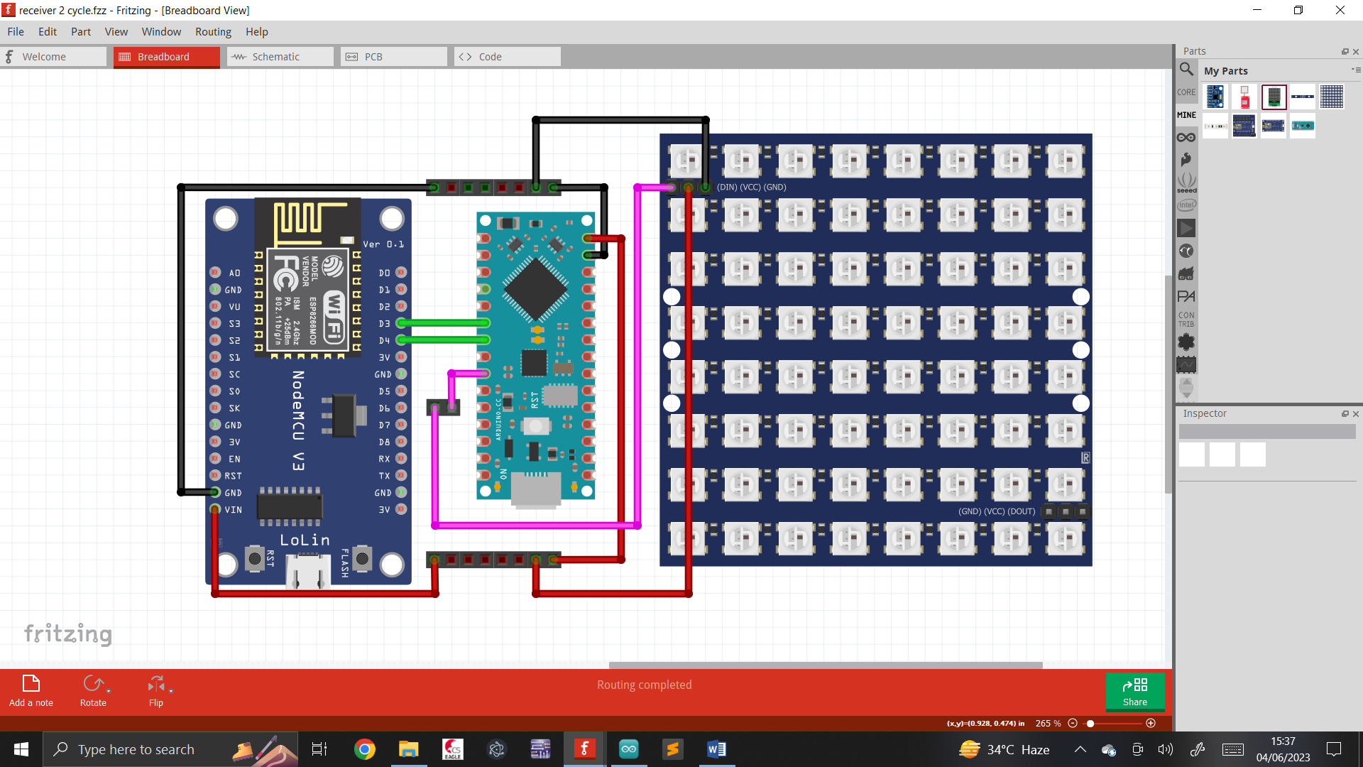

Transmitter Part

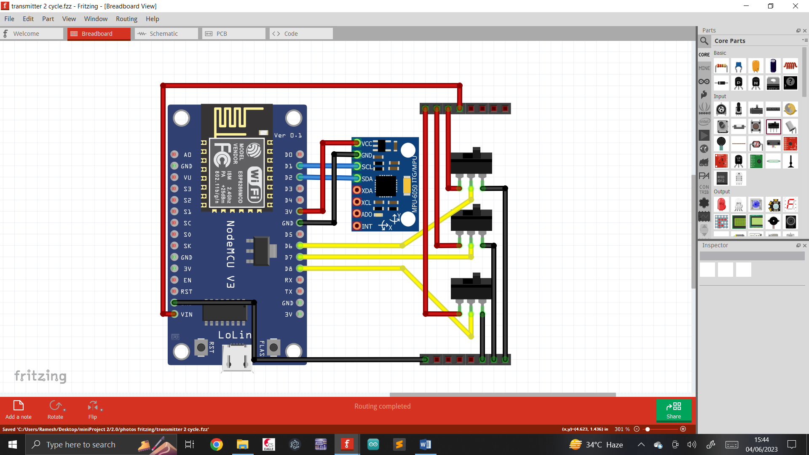

HARDWARE & SOFTWARE

|  |  |
| --- | --- |
| Hardware | Software |
| Nodemcu (ESP8266) | Arduino |
| Arduino Nano | Eagle |
| Sensor (MPU6050) | HTML |
| LED Matrix (WS2812B) | CSS |
| SPDT switch | Javascript |
| Breadboard | Fritzing |
| Jumper wire | Wokwi |
| Female Header |  |

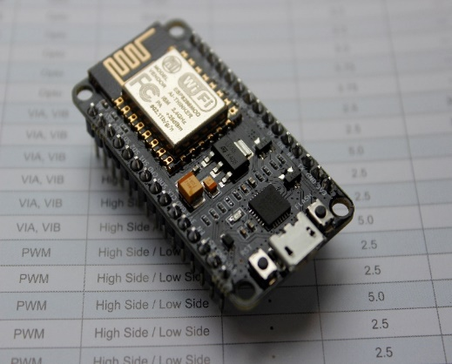

ESP8266 is a low-cost, Wi-Fi enabled chip that can be programmed with the Lua scripting language. The NodeMCU development board includes the ESP8266 chip, as well as a USB-to-serial converter, voltage regulator, and other components that make it easy to connect to a computer and start developing IoT applications.

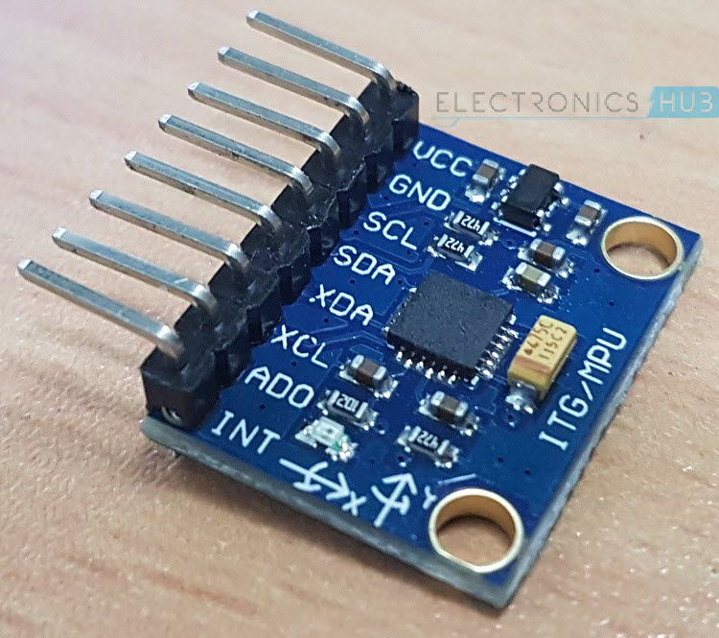

The MPU6050 is a 3-axis accelerometer and 3-axis gyroscope sensor module that is commonly used as a tilt sensor. It can detect changes in orientation relative to the gravity vector. This means that it can determine the angle of tilt or inclination of an object, making it a useful sensor for a wide range of applications such as drones, robots, and gaming controllers.

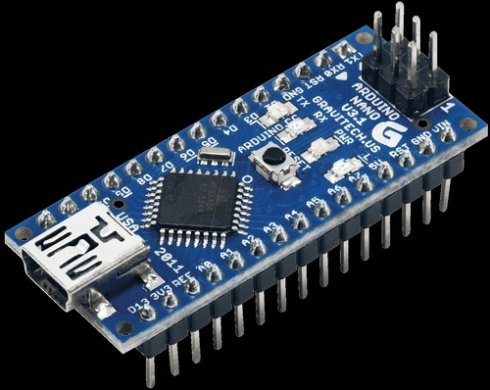

The Arduino Nano is a compact microcontroller board based on the ATmega328P. The board has a built-in USB-to-serial converter, which allows it to communicate with a computer via USB. It also has a dedicated I2C and SPI interface for connecting to other devices and sensors. It is a versatile and affordable board that is commonly used for robotics, automation, IoT, and prototyping

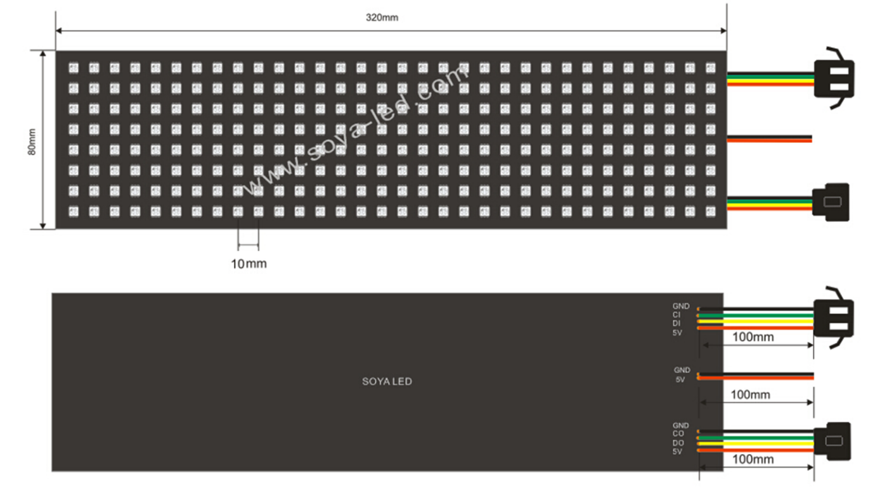

The WS2812B is a popular type of RGB LED (Red, Green, Blue Light-Emitting Diode) that comes in a small package with a built-in controller. Each LED in the matrix can be individually addressed and controlled, allowing for a wide range of visual effects, animations, and patterns.

WORKING

In this project we have used 2 microcontrollers. Let they be named as A & B. the microcontroller A is connected to MPU6050 sensor. It is a 3-axis gyro and 3-axis accelerometer. It can calculate various parameters like angle of rotation, gyration, acceleration etc. it is used to mesure the rotation of steering wheel. We have set the limit to 20 degrees. If steering wheel rotates beyond +20 we consider it as left turn. If steering wheel rotates beyond -20 we consider it as right turn. Otherwise we say steering is at neutral position. This is the automatic way of giving turn indication. Conventionally switches are used. We have also provided 2 switches for left and right turn. The provide manual control to user. This will ensure 2 fold security. Also a 3rd switch is provided which replicates the brakes. Apart from direction we have used MPU6050 to detect fall. To do this we calculate gyro values along X,Y,Z direction. We then take RMS value of it. This RMS value is checked again & again. Whenever an accident takes place there is drastic change in orientation of body within a fraction of second. after the accident the body becomes still and orientation remains constant forever. We use the same principle to detect fall. If a fall is detected what to do next. For that reason we made our own webpage. On the webpage you can monitor all the parameters of the vehicle in real time. Also a google map links is provided to know the exact position of victim during an accident. To illustrate this data we made use of HTML tables and meter bar. Table contains the status of various switches that are operated by the driver. And the meter bar shows the rotation of steering wheel in degrees. To make the structure of webpage we used HTML. For frontend we used CSS and for backend we used Javascript. The sending and receiving of data is done using websocket protocol. This enbled to update very quickly on webpage without needing to hit the refresh button again & again. The data i.e is being transmitted is in JSON format. This enabled ous to send multiple values simultaneously over the same channel easily. This webpage is hosted by microcontroller A. In our project microcontroller A is the server. We are using it in station mode. So which ever wifi router it gets connected to the IP address of that router will be the url of our webpage.

Now we come to the B microcontroller. It is connected to the LED matrix. Data is wirelessly sent from A to B using again websockets. This is done by connceting B to the IP address of that same router. So we can say that in this project there is 1 server and 2 clients. Both A & B are operated in station mode and connected to same WiFi. The job of B is to display data on LED matrix. When a left or right turn is made, a left or right arrow in displayed on matrix respectively. This LED matrix will be installed right above the number plate of vehicle so that it is clearly vissible. We are using an 8 X 32 matrix. This means a total of 256 RGB LEDs. So we can make 4 arrow symbol each of 8 X 8 dimmension. The color and timing of each of these LEDs can be configured separately as the have memory element. In order to obtain proper image on matrix it is very important to know how the LEDs are connected internally. In my matrix the LEDs are connected in snake like pattern. Simply turning ON & OFF is boring. So we turn on the arrows one by one to create a moving effect. There are a total of 4 arrows. As soon as 4th arrow glows entire matrix goes off & the cycle repeats itself. As disscussed later in this report the matrix did not work with nodemcu boards due to some reason. So we used arduino nano. Now nodemcu controls LED matric via arduino nano.

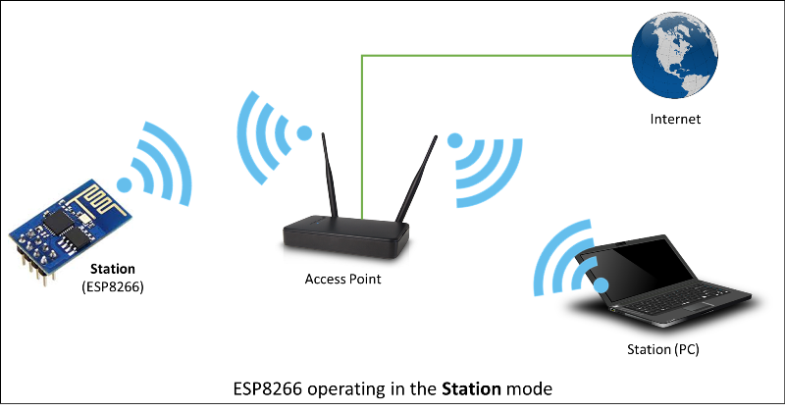

PCB MAKING

CLIENT

SERVER

ADVANTAGES

1. LEDs help to improves the visibility of the cyclist on road.
2. Fall detection & live tracking help in quick medical support.
3. Turn indication can be given both manually & automatically.
4. Websockets makes data transfer fast and super easy.
5. Location tracking done without using actual GPS module to reduce cost.
6. Entire webpage is made by ous to reduce project cost.
7. This device can be installed on any 2 wheeler like bike/scooter/cycle.

APPLICATIONS

1. Can by used by cyclist for personal safety during hiking & trekking.
2. Can be used by people participating in events like motor cyle race. It would help event organiser to monitor each participant.
3. Government & ministry of transport can play a key role by making this device as a compulsory upgrade in all the upcoming 2 wheelers.
4. The MPU6050 can be used to calculate various parameter like speed, distance, accident, engine temperature, steering position.
5. A separate webpage can be made for every bike rider and all the above parameters can be monitored in real time.
6. This details will prove to be very usefull for crime investigation incase of any accident. We can come to know who was exceeding speed limit.
7. With this device installed in bikes the workload of traffic police will reduce. Bikes exceeding speed limit will be automatically charged fine.

TOTAL COST

|  |  |  |
| --- | --- | --- |
| COMPONENT | QUANTITY | PRICE |
| Nodemcu (ESP8266) | 2 X 300 | 600 |
| LED Matrix (WS2812B) | 1 X 1700 | 1700 |
| Sensor (MPU6050) | 1 X 150 | 150 |
| Arduino Nano | 1 X 250 | 250 |
| SPDT Switch | 5 X 12 | 60 |
| TOTAL | | 2760 |

RESULT

1. Performed simulation of LED matrix on online simulator (Wokwi).
2. Successful data transmission between 2 microcontrollers.
3. Successful data transmission between webpage & microcontroller.
4. Live tracking using share my location, feature of google maps.
5. Providing manual control using SPDT switches.
6. Providing automatic control using MPU6050 sensor.
7. Interfaced input & output devices with microcontroller.
8. Programming microcontrollers using Arduino IDE.
9. Prototype successfully runs on breadboard as well as PCB.

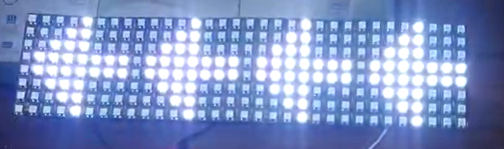

LED matrix indicating left when the vehicle tends to turn to the left.

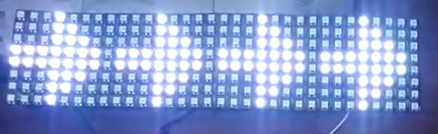

LED matrix indicating right when the vehicle tends to turn to the right.

FUTURE SCOPE

1. Calculating the total power consumption of the project.

2. To replace LED marix with cheaper alternative.

3. Testing the project on actual two-wheelers or cycles.

4. Adding new features like speedometer and odometer.

5. To reduce the number of microcontrollers from 3 to 2.

6. Upgrading half duplex communication to full duplex communication.

7. Adding the personal details of people on the webpage.

8. Creating N number of webpages for user data base.

REFERENCES

1. https://[github.com/jarzebski/Arduino-MPU6050](https://github.com/jarzebski/Arduino-MPU6050)
2. <https://howtomechatronics.com/tutorials/arduino/how-i2c-communication-works-and-how-to-use-it-with-arduino>[/](https://howtomechatronics.com/tutorials/arduino/how-i2c-communication-works-and-how-to-use-it-with-arduino/)
3. <https://circuitdigest.com/microcontroller-projects/arduino-multitasking-using-millis-in-arduino>
4. <https://www.elprocus.com/at-commands-tutorial/>
5. <https://www.latlong.net/Show-Latitude-Longitude.html>
6. <https://iotdesignpro.com/projects/websocket-server-with-esp32-and-arduino-ide>
7. <https://iotdesignpro.com/projects/real-time-data-transfer-between-two-esp32-using-websocket-client-on-arduino-ide>
8. <https://iotprojectsideas.com/iot-based-fall-detection-using-nodemcu-and-mpu6050-sensor/>
9. <https://github.com/mo-thunderz/Esp32WifiPart2>
10. <https://github.com/KrisKasprzak/ESP32_WebPage>

RESEARCH PAPERS

MPU-6050 Wheeled Robot Controlled Hand Gesture Using L298N Driver Based on Arduino

January 2023Journal of Physics Conference Series 2421(1):012022

DOI:10.1088/1742-6596/2421/1/012022

License CC BY 3.0

2. Methods 2.1.

Design Methodology The implementation process begins with system design then analyses the software and hardware requirements according to the design that has been made. After all components are available, the software and hardware system integration process will be carried out separately. After the software and hardware systems have been successfully created, the system testing process will then be carried out. If the test is successful, each component will be ready for use and the implementation process will be carried out, namely combining software and hardware systems into one interconnected system. 2.2. System planning To simplify system design, a system block diagram program is needed where each block has a specific function and way of working: MPU-6050 Serves as a movement medium in the electronic system of the robot where the movement of the robot (right, left, up, down) is controlled by the MPU-6050. Arduino Nano functions as a controller in the robot system which includes the MPU-6050, Motor Driver L298N, and NRF24L01. NRF24L01 Serves as a communication medium that is connected between the robot system movement and the hand gesture movement system. Motor Driver L298N moves according to the signal sent by the MPU-6050 sensor. Motor Driver L298N functions as an output medium connected to a DC motor. Motor Driver L298N will command the DC motor to move according to the signal sent by the MPU-6050 module.

GPS Based Vehicle Tracking System

June 2021International Journal of Scientific & Technology Research 10(04):278-282

Project: Vehicle Tracking

Authors:

Mohd Hakimi Zohari

University Tun Hussein Onn Malaysia

2 METHODOLOGY

2.1 Overview of Purpose System

Based on block diagram from Figure 1, Arduino MEGA is used to control the whole process between GPS module and GSM module. GPS module is used to get the coordinates of the vehicle while GSM module is used for sending coordinates to user by message. In order to track the vehicle location, first it needs to find the coordinates of vehicle. GPS module will connect with satellite continuously to get the coordinates. Then GPS will send the coordinates to Arduino UNO. Arduino MEGA will extract the required data that received by GPS. When GSM module receive command from user by massage, GSM module will cooperate with Arduino MEGA to reply the message and send it to user by using GSM module. The message contains the coordinates of vehicle location. Figure 2 shows the flowchart of GPS Based Vehicle Tracking System. First, GPS will be connecting continuously with satellite to routing the coordinate. Once the LED at GPS module was blinking, it means the location was locked. Then, check the LED at GSM Module. It will blinking after get the mobile communication line. After all LED was blinking, user can sent ―START‖ to GSM module via massage. GSM will reply the message. The message will contain location of vehicle detail and URL link to Google Maps. The location will be updated every one minute. In order to terminate the system, user just need to sent ―STOP‖ to GSM. Then, the system will stop sending message to user’s phone

CHALLENGES

1. The main idea was to successfully do wireless communicaion between 2 microcontrollers. But later we decided to upgrade the project by making a webpage. The simplest way is to use online IOT platforms like ThingSpeak, Blynk, IFTTT etc. These platforms provide readymade widgets and look after the backend operations of webpage. However they provide these services in the form of monthly subscriptions. So I decided to create my own webpage from scratch using programming languages like javascript, HTML, CSS. It made our device plateform independent and also provided greater flexibility in terms of designing webpage. It reduced the cost of project drastically.

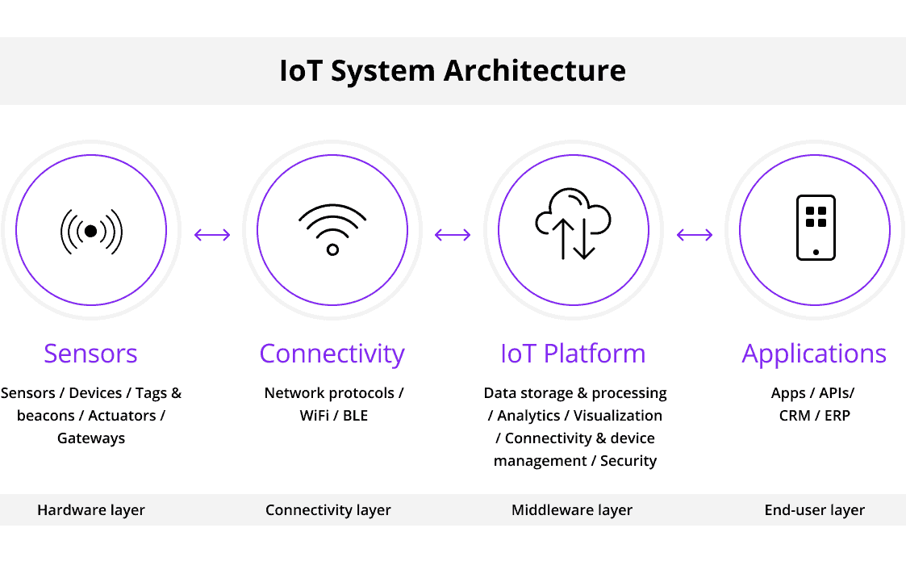

1. 2 microcontroller are sufficient for making this project. 1uc will fetch data from sensor and 2nd uc will display it on LED matrix. However due to some reason my LED matrix did not work with either of ESP8266 boards. I had no other choice but to use an extra board (arduino nano) for LED matrix. Due to this the cost of project went up as now I have 3uc instead of 2uc.
2. Another important decision I took was to shift from HTTP protocol to websocket protocol. HTTP protocol was working fine for uc to uc communication but when I started communication between webpage and uc I faced lot of issues. Every time I had to update data on webpage I had to hit the refresh button. This is because HTTP works on request-response model. Finally I decided to perform both the tasks using websockets as it allows real time 2 way communication.

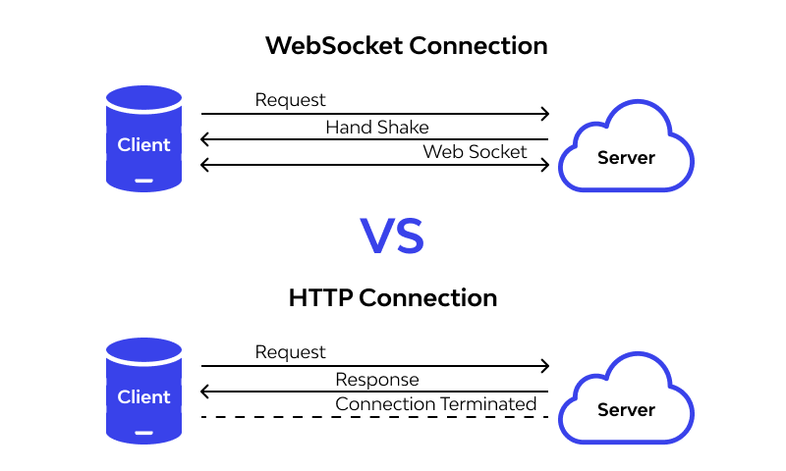

1. MPU6050 can accurately calculate angle for rotation along X & Y axis. This is because these movents are against the Earth’s gravitational force. But we are intrested in rotation along Z axis because steering wheel rotates along Z axis. But unfortunately MPU6050 does not calculate angle Z with precision. So we make some modifaction using bevel gears. They convert rotation along vertical axis into rotaion along horizontal axis. This solve our problem to a great extent.

